# Power BI Assignment – 1

**• Install Power BI Desktop and share the final screenshot of the report view page which appears when power desktop starts.**

Installed Power BI Desk top and using free trial.

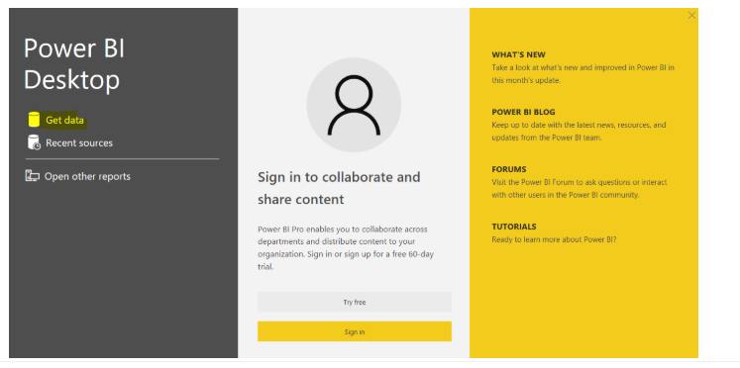

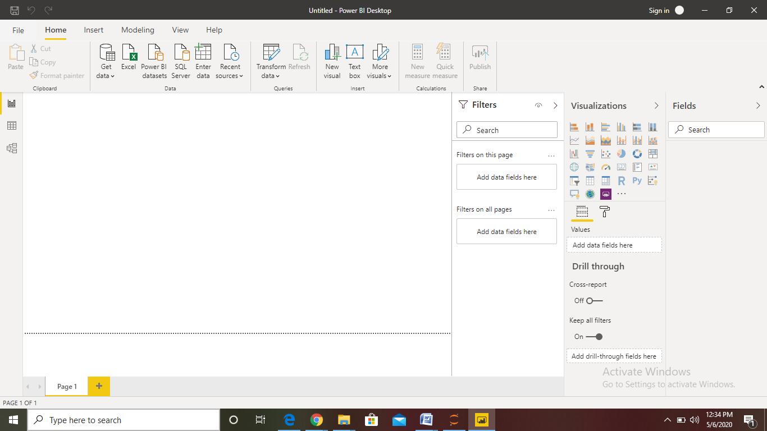

**• Prepare a document and with the following screenshot − Report View − Data View − Model View − Power Query Editor − Advance Editor**

**Report View:**

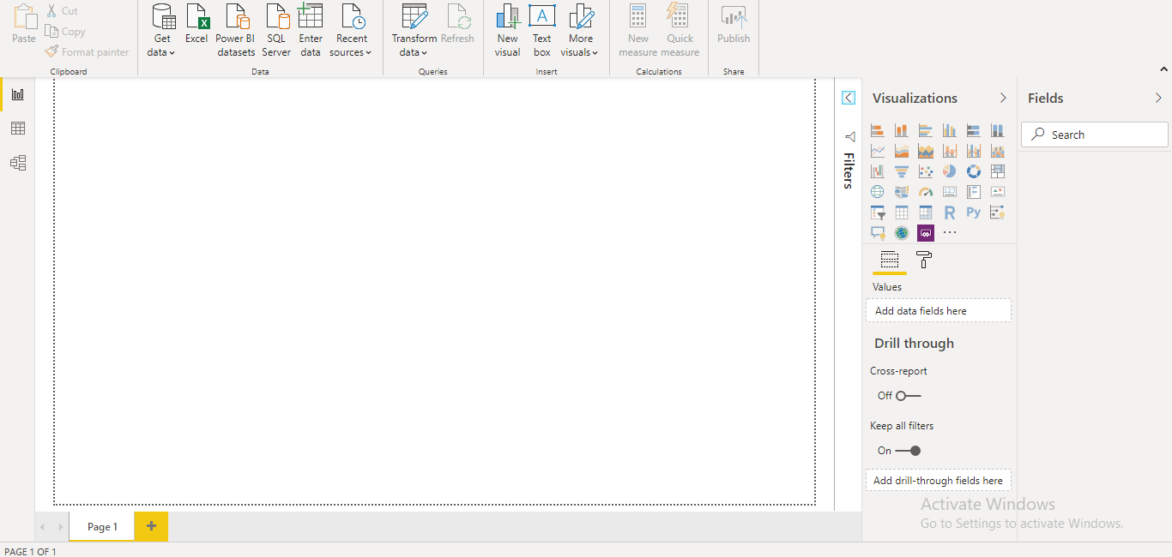

If you've been working with Power BI, you know how easy it's to create reports providing dynamic perspectives and insights into your data. Power BI also has more advanced features in Power BI Desktop. With Power BI Desktop, create advanced queries, mashup data from multiple sources, create relationships between tables, and more.

Power BI Desktop includes a Report view, where you can create any number of report pages with visualizations. Report view in Power BI Desktop provides a similar design experience to the report's editing view in the Power BI service. You can move visualizations around, copy and paste, merge, and so on.

The difference between them is when using Power BI Desktop, you can work with your queries and model your data to make sure your data supports the best insights in your reports. You can then save your Power BI Desktop file wherever you like, whether it's your local drive or to the cloud.

**Data View:**

*Data view* helps you inspect, explore, and understand data in your *Power BI Desktop* model. It's different from how you view tables, columns, and data in *Power Query Editor*. With Data view, you're looking at your data *after* it has been loaded into the model.

When you're modeling your data, sometimes you want to see what's actually in a table or column without creating a visual on the report canvas. You might want to see right down to the row level. This ability is especially useful when you're creating measures and calculated columns, or you need to identify a data type or data category.

Let's take a closer look at some of the elements found in Data view.

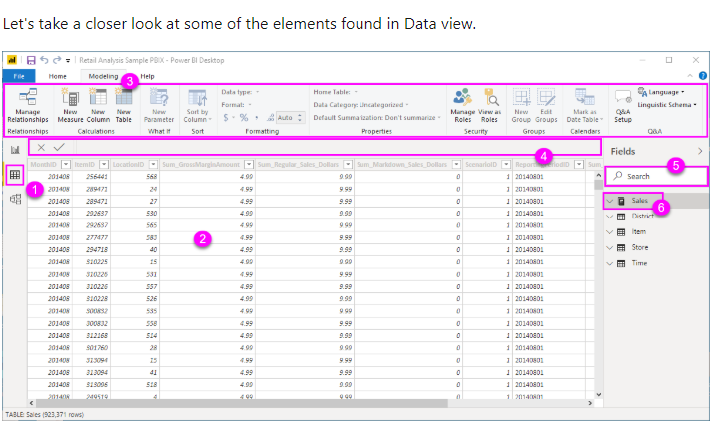

1. **Data view icon**. Select this icon to enter Data view.
2. **Data Grid**. This area shows the selected table and all columns and rows in it. Columns hidden from Report view are greyed out. You can right-click on a column for options.
3. **Modeling ribbon**. Here you can manage relationships, create calculations, change data type, format, data category for a column.
4. **Formula bar**. Enter Data Analysis Expression (DAX) formulas for Measures and Calculated columns.
5. **Search**. Search for a table or column in your model.
6. **Fields list**. Select a table or column to view in the data grid.

**Model View :**

*It*  shows all of the tables, columns, and relationships in your model. This view can be especially helpful when your model has **complex relationships between many tables**.

Select the **Model** icon near the side of the window to see a view of the existing model. Hover your cursor over a relationship line to show the columns that are used.

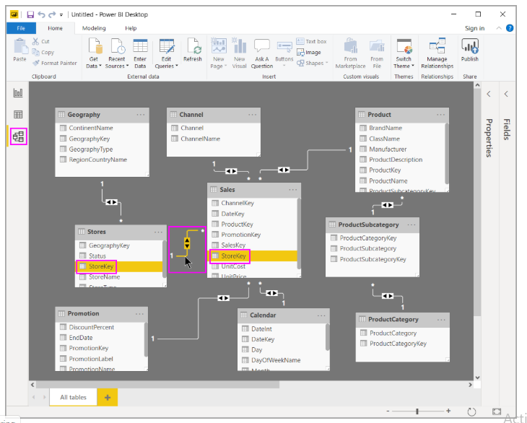

In the figure, the Stores table has a StoreKey column that’s related to the Sales table, which also has a StoreKey column. The two tables have a Many to One (*:1) relationship. An arrow in the middle of the line shows the direction of the filter context flow. The double arrows mean the cross-filter direction is set to Both.

You can double-click a relationship to open it in the **Edit Relationship** dialog box.

**Power Query Editor:**

Power BI Desktop also comes with Power Query Editor. Use Power Query Editor to connect to one or many data sources, shape and transform the data to meet your needs, then load that model into Power BI Desktop.

With no data connections, Power Query Editor appears as a blank pane, ready for data.

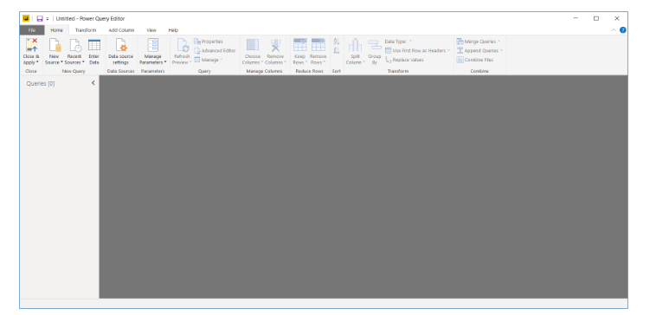

Once a query is loaded, Power Query Editor view becomes more interesting. If we connect to the following Web data source, Power Query Editor loads information about the data, which you can then begin to shape:

Here’s how Power Query Editor appears once a data connection is established:

1. In the ribbon, many buttons are now active to interact with the data in the query.
2. In the left pane, queries are listed and available for selection, viewing, and shaping.
3. In the center pane, data from the selected query is displayed and available for shaping.
4. The **Query Settings** pane appears, listing the query’s properties and applied steps.

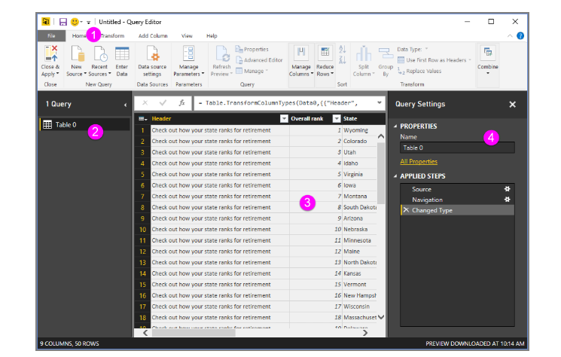

## The query ribbon

The ribbon in Power Query Editor consists of four tabs: **Home**, **Transform**, **Add Column**, and **View**.

The **Home** tab contains the common query tasks.

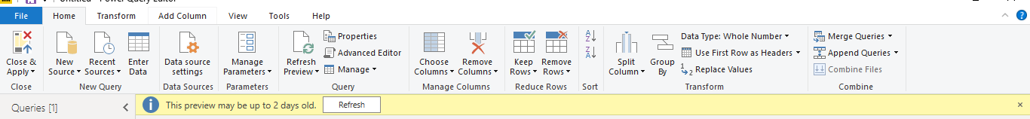

To connect to data and begin the query building process, select **New Source**. A menu appears, providing the most common data sources.

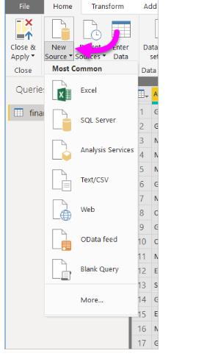

The **Transform** tab provides access to common data transformation tasks, such as:

* Adding or removing columns
* Changing data types
* Splitting columns
* Other data-driven tasks



The **Add Column** tab provides additional tasks associated with adding a column, formatting column data, and adding custom columns. The following image shows the **Add Column** tab.

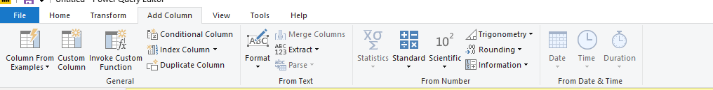

The **View** tab on the ribbon is used to toggle whether certain panes or windows are displayed. It’s also used to display the Advanced Editor. The following image shows the **View** tab.

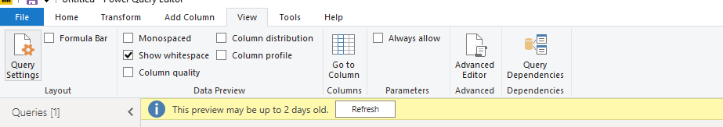

It’s useful to know that many of the tasks available from the ribbon are also available by right-clicking a column, or other data, in the center pane.

## The left (Queries) pane

The left pane, or **Queries** pane, displays the number of active queries and the name of the query. When you select a query from the left pane, its data is displayed in the center pane, where you can shape and transform the data to meet your needs. The following image shows the left pane with a query.

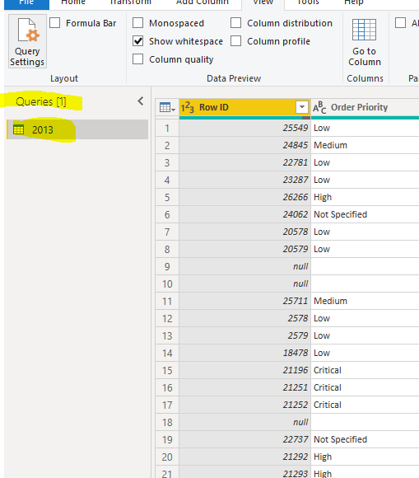

## The center (Data) pane

In the center pane, or **Data** pane, data from the selected query is displayed. This pane is where much of the work of the **Query** view is accomplished.

In the following image shows the Web data connection established earlier. The **Product** column is selected, and its header is right-clicked to show the available menu items. Notice that many of these right-click menu items are the same as buttons in the ribbon tabs.

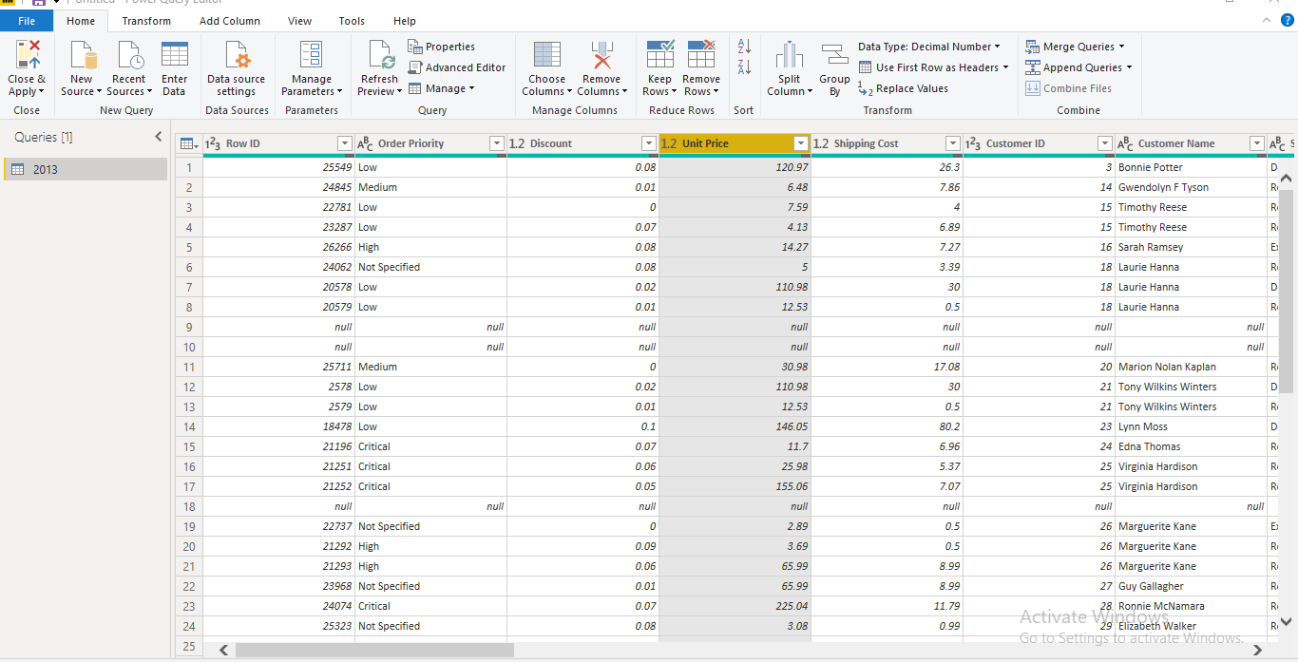

When you select a right-click menu item (or a ribbon button), the query applies the step to the data. It also saves step as part of the query itself. The steps are recorded in the **Query Settings** pane in sequential order, as described in the next section.

## The right (Query Settings) pane

The right pane, or **Query Settings** pane, is where all steps associated with a query are displayed. For example, in the following image, the **Applied Steps** section of the **Query Settings** pane reflects the fact that we just changed the type of the **Overall score** column.

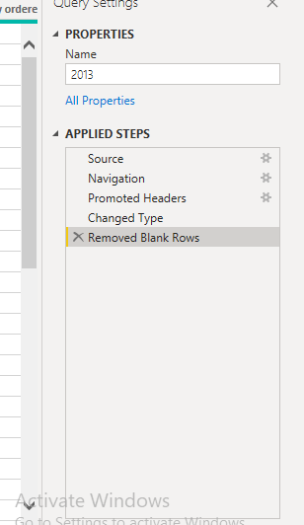

As additional shaping steps are applied to the query, they're captured in the **Applied Steps** section.

It’s important to know that the underlying data isn't changed. Rather, Power Query Editor adjusts and shapes its view of the data. It also shapes and adjusts the view of any interaction with the underlying data that occurs based on Power Query Editor’s shaped and modified view of that data.

In the **Query Settings** pane, you can rename steps, delete steps, or reorder the steps as you see fit. To do so, right-click the step in the **Applied Steps** section, and choose from the menu that appears. All query steps are carried out in the order they appear in the **Applied Steps** pane.

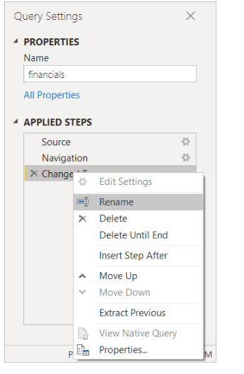

The **Advanced Editor** lets you see the code that Power Query Editor is creating with each step. It also lets you create your own shaping code. To launch the advanced editor, select **View** from the ribbon, then select **Advanced Editor**. A window appears, showing the existing query code.

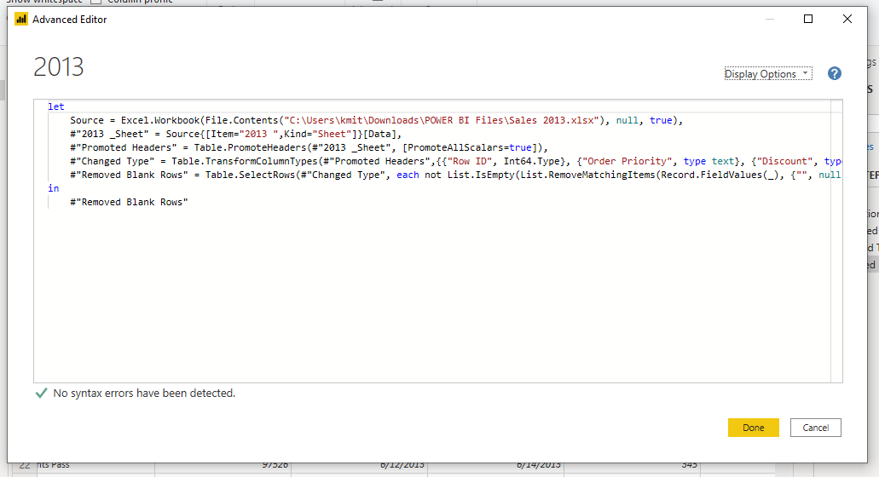

You can directly edit the code in the **Advanced Editor** window. To close the window, select the **Done** or **Cancel** button.

## Saving your work

When your query is where you want it, select **Close & Apply** from Power Query Editor's **File** menu. This action applies the changes and closes the editor.

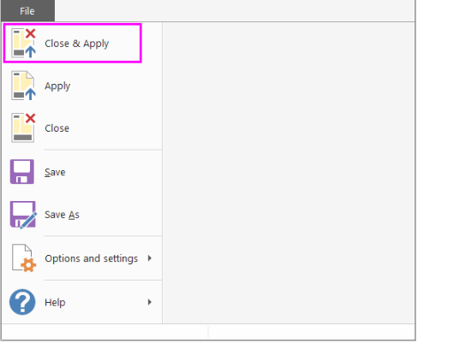

As progress is made, Power BI Desktop provides a dialog to display its status.

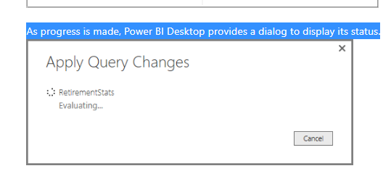

When you're ready, Power BI Desktop can save your work in the form of a .pbix file.

To save your work, select **File** > **Save** (or **File** > **Save As**), as shown in the following image.

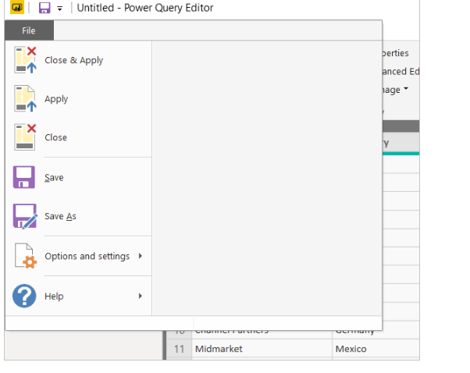

# • Prepare a document with details of the following along with their price − Power BI Desktop − Power BI Pro − Power BI Premium

Microsoft Power BI is a cloud-based business intelligence and analytics service that provides a full overview of your most critical data. Connecting to all of your data sources, Power BI simplifies data evaluation and sharing with scalable dashboards, interactive reports, embedded visuals and more.

Power BI has three pricing plans:

* **Power BI Desktop**: This offering is free to any single user and includes data cleaning and preparation, custom visualizations and the ability to publish to the Power BI service.
* **Power BI Pro**: The Pro plan costs $9.99/user/month. It includes data collaboration, data governance, building dashboards with a 360-degree real-time view and the ability to publish reports anywhere. Users can try it a free trial for 60 days before purchasing the subscription.
* **Power BI Premium:** The Premium plan starts at $4,995 a month per dedicated cloud compute and storage resource.